Q1 Generate Movie Ticket

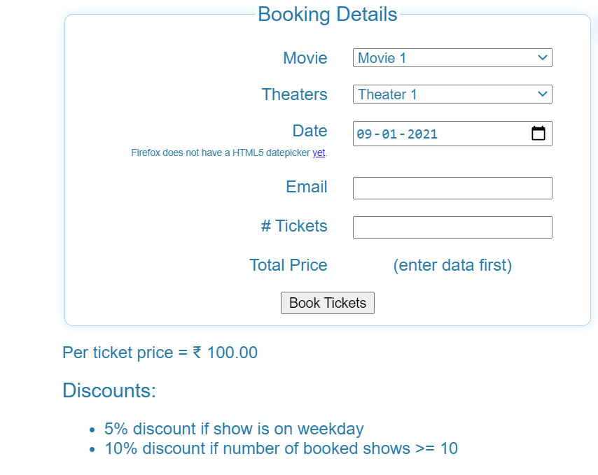

Show Movie Ticket with Poster According Above interface and criteria

Hint to get week day

d.getDay() return weekday in number format for ex. 0-Sunday 1-Monday ….

d.getMonth(),d.getFullYear() & getDate() are some other functions of date

***Example***

***var days = ['Sunday', 'Monday', 'Tuesday', 'Wednesday', 'Thursday', 'Friday', 'Saturday'];***

***var d = new Date(bookingdate.value); //bookingdate is id***

***var dayName = days[d.getDay()];***

Q2. Generate Railway Tickets According to Following Interface

